

**PROJECT REPORT**

**OF**

**ENGINEERING EXPLORATION**

**AT**

**CHITKARA UNIVERSITY**

**IN**

**COMPUTER SCIENCE AND ENGINEERING**

**ON**

**LIBRARY MANAGEMENT SYSTEM**

**SUBMITTED IN PARTIAL**

**FULFILLMENT OF THE DEGREE**

**OF**

**B.E - M.E(Int.)**

**Under the Guidance of: Submitted By:**

**Name: Mukesh Kumar Name: Aryan Kathpal**

**Department: Computer Science Engineering University ID No.:1911985021**

Chitkara University, Himachal Pradesh,

India.

***Acknowledgement***

I would like to show my sincere gratitude to all those who helped me in the completion of this project. During the work I faced many challenges due to my lack of knowledge and experience but these people helped me to get over from all the difficulties and in final compilation of my idea to a well shaped project.

I acknowledge with thanks the kind patronage and timely guidance of ***Mukesh Kumar*** because of whom I was able to learn the minute aspects of project work.

I express deep and sincere gratitude to ***Kuldeep Kumar*** (Head, Department of Computer Science & Engineering), whose guidance, encouragement, suggestion and very constructive criticism have contributed immensely to the evolution of my ideas on the project.

Finally I would like to thank the management of Chitkara School of Engineering and Technology Baddi for providing me such an opportunity to learn from these experiences.

**Aryan Kathpal**

***Certificate***

Certified that this is a bonafide record of the project work titled “LIBRARY MANAGEMENT SYSTEM”

Done by : **Aryan Kathpal**

***Abstract***

It is a great opportunity for me to be studying Web Development in Chitkara University, Baddi for my B.Tech-M.Tech(Int.). In the partial accomplishment of this degree I am submitting a project report on FULL STACK DEVELOPMENT on the topic Library Management.

Library management system is a project which aims in developing a computerized system to maintain all the daily work of the library .This project has many features which are generally not available in normal library management systems like facility of user login.

It also has a facility of admin login through which the admin can monitor the whole system. It has also a facility where students after logging in their accounts can see the list of books issued and its issue date and return date.

Overall this project is developed to help the students as well as staff of the library to maintain the library in the best way possible and also reduce the human efforts.

***List of Figures :***

1. Books Model 17
2. Users Model 17
3. Issued-Books Model 18
4. Fines Model 18
5. Requested Books Model 18
6. Returned Books Model 19

***Content :***

**Acknowledgement……………………………………………………2**

**Certificate..……………………………………………………………3**

**Abstract……………………………………………………………….4**

**List of Figures…………………………………………………………5**

1. **INTRODUCTION..…………………………………………….….8**
2. **SYSTEM ANALYSIS……………………………………….…….10**

**3. SYSTEM DESIGN. . .……………………………………………..16**

**4. SYSTEM IMPLEMENTATION . . .……………………………...19**

**5. TESTING..……………………………………………………........20**

**6. RESULTS (Screenshots)..…………………………………………22**

**7. FUTURE ENHANCEMENTS……………………………………**

**8. CONCLUSION……………………………………………………**

**9. DATA SET (Links)…………………………………………………**

**10. BIBLIOGRAPHY…………………………………………………**

***1. INTRODUCTION***

**1.1.**  **PROJECT AIMS AND OBJECTIVES**

The project aims and objectives that will be achieved after its completion, are discussed in this subchapter. The aim is to achieve and implement the following:

* Make it easier to manage books
* Reduce paperwork
* User Sign-Up
* User Log-In
* A column for digital library
* A search column to search a certain book
* Online book issue
* Request column for librarian for providing new books
* Admin Login.
* Admin delete lost books
* Admin update book record
* Admin add a book
* Admin accepts book requests.

#### 

**1.2.**  **BACKGROUND OF PROJECT**

Library Management System is an application which refers to library systems which are generally small or medium in size. It is used by librarians to manage the library using a computerized system where he/she can record various transactions like issue of books, return of books, addition of new books, addition of new students etc.

Books and student maintenance modules are also included in this system which would keep track of the students using the library and also a detailed description about the books a library contains. With this computerized system there will be no loss of book record or member record which generally happens when a non computerized system is used.

In addition, the report module is also included in the Library Management System. If the user's position is admin, the user is able to add new books, delete a lost book and update an existing record.

The library management system software records all this data. This saves time, effort and money. The librarian’s work becomes less tiresome. The automatic process reduces the chance of errors thereby increasing the accuracy of the records. The user-friendly interface increases member engagement and improves the efficiency of the library.

All these modules are able to help librarians to manage the library with more convenience and in a more efficient way as compared to library systems which are not computerized.

***2. SYSTEM ANALYSIS***

In this chapter, we will discuss and analyze the developing process of the Library Management System including software requirement specification (SRS) and comparison between existing and proposed systems . The functional and nonfunctional requirements are included in the SRS part to provide complete description and overview of system requirements before the developing process is carried out. Besides that, existing vs proposed provides a view of how the proposed system will be more efficient than the existing one.

**2.1. SOFTWARE REQUIREMENT SPECIFICATION**

**2.1.1**. **GENERAL DESCRIPTION**

**PRODUCT DESCRIPTION:**

Library Management System is a computerized system which helps the user(librarian) to manage the library daily activity in electronic format. It reduces the risk of paper work such as file loss, file damage and time consuming.

It can help users to manage the transaction or record more effectively and time- saving.

**PROBLEM STATEMENT:**

The problem occurred before having computerized system includes:

* **File lost**

When a computerized system is not implemented a file may be lost because of the human environment. Sometimes due to some human error there may be a loss of records. File damaged When a computerized system is not there file is always lost due to some accident like spilling of water by some member on fileaccidentally.Besides some natural disaster like floods or fires may also damage the files.

* **Difficult to search record**

When there is no computerized system there is always a difficulty in searching for records if the records are large in number .

* **Space Consuming**

After the number of records becomes large the space for physical storage of file and records also increases if no computerized system is implemented.

* **Cost consuming**

As there is no computerized system to add each record paper will be needed which will increase the cost for the management of the library.

#### **2.1.2 SYSTEM OBJECTIVES**

* ·  **Improvement in control and performance**

The system is developed to cope up with the current issues and problems of the library.The system can add users, validate users and is also bug free.

* · **Save Cost**

After the computerized system is implemented less human force will be required to maintain the library thus reducing the overall cost.

* ·  **Save Time**

Librarian is able to search records by using a few clicks of mouse and few search keywords thus saving his valuable time.

**2.1.3 SYSTEM REQUIREMENTS**

2.1.3.1 NON FUNCTIONAL REQUIREMENTS

* **Product Requirements**

EFFICIENCY REQUIREMENT

When a library management system will be implemented, librarians and users will easily access the library as searching and book transactions will be much faster .

RELIABILITY REQUIREMENT

The system should accurately performs member registration ,member validation , report generation, book transaction and search

USABILITY REQUIREMENT

The system is designed for a user-friendly environment so that students and staff of the library can perform the various tasks easily and in an effective way.

* **Organizational Requirements**

IMPLEMENTATION REQUIREMENTS

In implementing the whole system it uses react in front end with NodeJS as server side scripting language which will be used for database connectivity and the backend i.e. the database part is developed using MongoDB.

DELIVERY REQUIREMENTS

The whole system is expected to be delivered in a month's time with a weekly evaluation by the project guide.

* + **Functional requirements**
    1. User Sign-Up
    2. User Log-In
    3. A column for digital library
    4. A search column to search a certain book
    5. Online book issue
    6. Request column for librarian for providing new books
    7. User information page where users can find books issued and their return date.
    8. Admin Login.
    9. Admin can delete lost books
    10. Admin can update book record
    11. Admin can add a book

#### **2.1.4 SOFTWARE AND HARDWARE REQUIREMENTS**

This section describes the software and hardware requirements of the system

2.1.4.1 SOFTWARE REQUIREMENTS

Operating system- Windows 7 and above is recommended as the operating system as it is stable and supports more features and is more user friendly

2.1.4.2 HARDWARE REQUIREMENTS

Intel core i5 2nd generation is used as a processor because it is faster than other processors and provides reliability and stability and we can run our pc for longtime. By using this processor we can keep on developing our project without any worries.

**2.2. SOFTWARE TOOLS USED**

**MERN Stack**: MERN Stack is a Javascript Stack that is used for easier and faster deployment of full-stack web applications. MERN Stack comprises 4 technologies namely: MongoDB, Express, React and Node.js. It is designed to make the development process smoother and easier..

**1. MongoDB: Cross-platform Document-Oriented Database**

MongoDB is a NoSQL database where each record is a document consisting of key-value pairs that are similar to JSON (JavaScript Object Notation) objects. MongoDB is flexible and allows its users to create schema, databases, tables, etc. Documents that are identifiable by a primary key make up the basic unit of MongoDB. Once MongoDB is installed, users can make use of the Mongo shell as well. Mongo shell provides a JavaScript interface through which the users can interact and carry out operations (eg: querying, updating records, deleting records).

Why MongoDB?

* Fast – Being a document-oriented database, easy to index documents. Therefore a faster response.
* Scalability – Large data can be handled by dividing it into several machines.
* Use of JavaScript – MongoDB uses JavaScript which is the biggest advantage.
* Schema Less – Any type of data in a separate document.
* Data stored in the form of JSON
* JSON syntax is very easy to use.
* JSON has a wide range of browser compatibility.
* Sharing Data: Data of any size and type(video, audio) can be shared easily.
* Simple Environment Setup – Its really simple to set up MongoDB.

**2. Express: Back-End Framework:**

Express is a Node.js framework. Rather than writing the code using Node.js and creating loads of Node modules, Express makes it simpler and easier to write the back-end code. Express helps in designing great web applications and APIs. Express supports many middlewares which makes the code shorter and easier to write.

Why Express?

* Asynchronous and Single-threaded.
* Efficient, fast & scalable
* Has the biggest community for Node.js
* Express promotes code reusability with its built-in router.
* Robust API

**3. React: Front-End Library**

React is a JavaScript library that is used for building user interfaces. React is used for the development of single-page applications and mobile applications because of its ability to handle rapidly changing data. React allows users to code in JavaScript and create UI components.

Why React?

* Virtual DOM – A virtual DOM object is a representation of a DOM object. Virtual DOM is actually a copy of the original DOM. Any modification in the web application causes the entire UI to re-render the virtual DOM. Then the difference between the original DOM and this virtual DOM is compared and the changes are made accordingly to the original DOM.
* JSX – Stands for JavaScript XML. It is an HTML/XML JavaScript Extension which is used in React. Makes it easier and simpler to write React components.
* Components – ReactJS supports Components. Components are the building blocks of UI wherein each component has a logic and contributes to the overall UI. These components also promote code reusability and make the overall web application easier to understand.
* High Performance – Features like Virtual DOM, JSX and Components makes it much faster than the rest of the frameworks out there.

**4. Node.js: JS Runtime Environment**

Node.js provides a JavaScript Environment which allows the user to run their code on the server (outside the browser). Node pack manager i.e. npm allows the user to choose from thousands of free packages (node modules) to download.

Why Node.JS?

* Open-source JavaScript Runtime Environment
* Single threading – Follows a single-threaded model.
* Data Streaming
* Fast – Built on Google Chrome’s JavaScript Engine, Node.js has a fast code execution.
* Highly Scalable

#### **2.3 EXISTING VS PROPOSED SYSTEM**

* Existing system does not have any facility of admin login or student login where as proposed system will have a facility of student login as well as admin login
* Existing system does not has any facility for book request suggestions where as in proposed system after logging in to their accounts student can request books as well as provide suggestions to improve library

***3. SYSTEM DESIGN***

**3.1. Table Design :**

***3.1.1. Books Model***

| **Field Name** | **Type Name** | **Required** | **Extra** |
| --- | --- | --- | --- |
| name | String | True | - |
| image | String | - | - |
| author | String | True | - |
| book_depository_stars | Integer | - | - |
| isbn | Integer | True | Unique |
| category | String | True | - |
| copies | Integer | - | Default : 1 |
| pages | Integer | - | Default : 1 |

***3.1.2. User Model***

| **Field Name** | **Type Name** | **Required** | **Extra** |
| --- | --- | --- | --- |
| name | String | True | - |
| email | String | True | Unique |
| password | String | True | - |
| role | String | - | Default : User |

***3.1.3. Issued-Books Model***

| **Field Name** | **Type Name** |
| --- | --- |
| userId | String |
| Name | String |
| image | String |
| author | String |
| isbn | Integer |
| IssuedOn | String |
| returnDate | String |

***3.1.4. Requested-Books Model***

| **Field Name** | **Type Name** | **Required** | **Extra** |
| --- | --- | --- | --- |
| name | String | True | - |
| author | String | True | - |
| username | String | True | - |
| status | String | - | Default : Pending |

***3.1.6. Fines Model***

| **Field Name** | **Type Name** |
| --- | --- |
| userId | String |
| fine | Integer |

***3.1.6. Returned-Books Model***

| Field Name | Type Name |
| --- | --- |
| userId | String |
| Name | String |
| author | String |
| isbn | Integer |
| IssuedOn | String |
| returnedOn | String |
| dueDate | String |
| fine | Integer |

**3.2. Class/DFD/ER Diags**

***4. SYSTEM IMPLEMENTATION : MODULE DESCRIPTION***

**4.1. ADMIN MODULE**

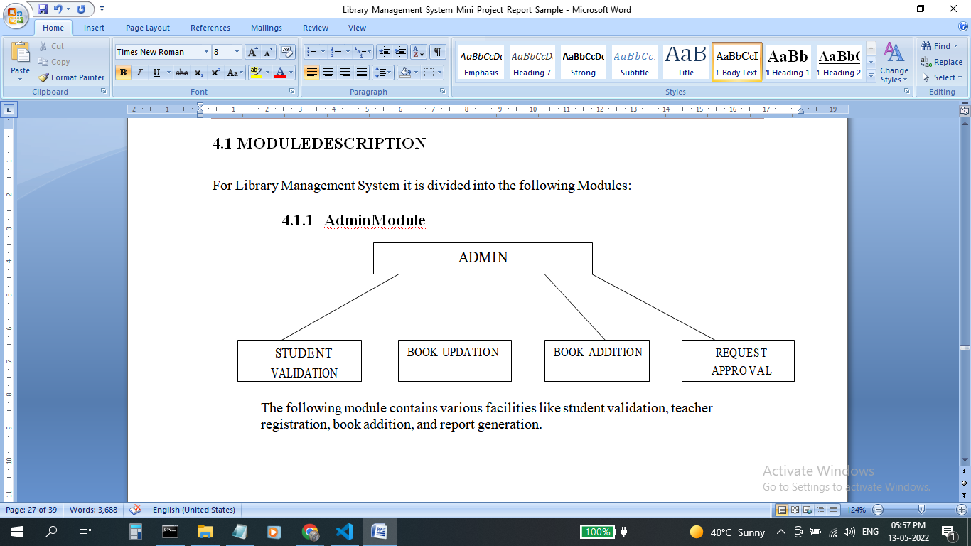

**4.2. USER MODULE**

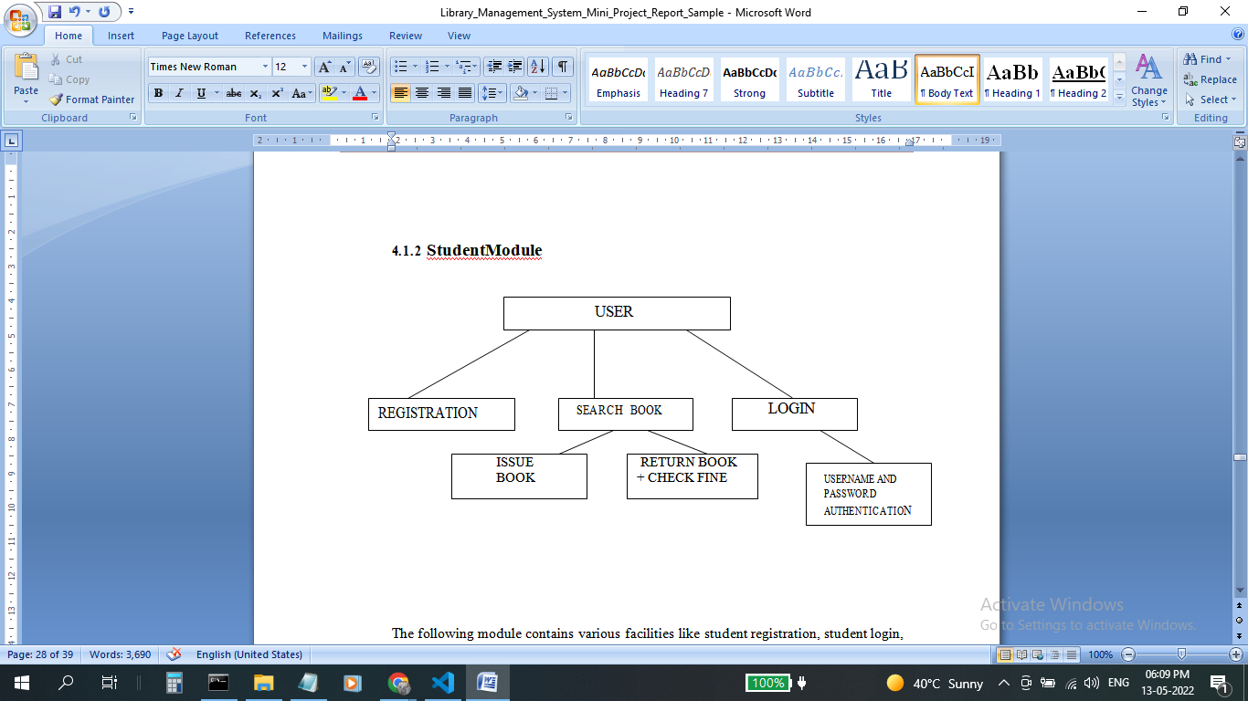

***5. TESTING***

The aim of the system testing process was to determine all defects in our project .The program was subjected to a set of test inputs and various observations were made and based on these observations it will be decided whether the program behaves as expected or not.

***5.1. Unit testing***

A “test.js” file has been created that checks various api endpoints and returns the number of tests passing or failing .

***5.2. Integration testing***

Integration testing is undertaken when all modules have been created and successfully reviewed. In order to test a single module we need to provide a complete environment ie besides the module we would require

* The procedures belonging to other modules that the module under test calls
* Non local data structures that module accesses
* A procedure to call the functions of the module under test with appropriate parameters

Unit testing was done on each and every module that is described under module description of chapter 4

**1. Test For the Admin module**

* Testing admin login form - This form is used for login of the administrator of the system. In this we enter the username and password if both are correct administration page will open otherwise if any of data is wrong it will get redirected back to the login page and again ask for username and password
* Book Addition- Admin can enter details of books and can add the details to the main book table also he can view the books requests.

* Book Updation- Admin can enter details of books and can add the details to the main book table also he can view the books requests.

**2. Test for User module**

* Test for Student login Form - This form is used for login of Student .In this we enter the library id, username and password if all these are correct student login page will open otherwise if any of data is wrong it will get redirected back to the login page and again ask for library id, username and password.
* Test for book issue - User searches a book and clicks on the issue button ; if the book gets issued the toast for success is generated else warning is shown. If successful the book can then be seen in the Issued books tab.
* Test for returning book - User goes to the issued page and clicks on return book; if successful user gets the success message and the book is removed from the issued page. The user is able to view it on the returned books page.
* Test for requesting a book - User goes to the request books page and the details; if a successful user gets the success message and the book is added to the list . The user is able to view it’s status on the table.

***6. RESULTS***

Deployed application is successfully tested and manifests appropriate and desired results against all possible inputs. Application and user information is secured and no crucial information is stored in local storage or in cookies making the application reliable.

Built application is robust and highly scalable making it accessible anytime, anywhere and on any type of device.

**LANDING PAGE**

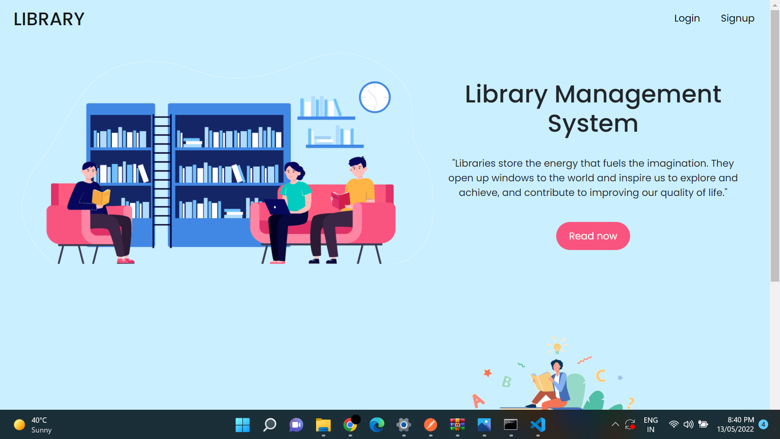

**—---------------------------------------- U S E R —-------------------------------------**

**BOOKS CATALOG**

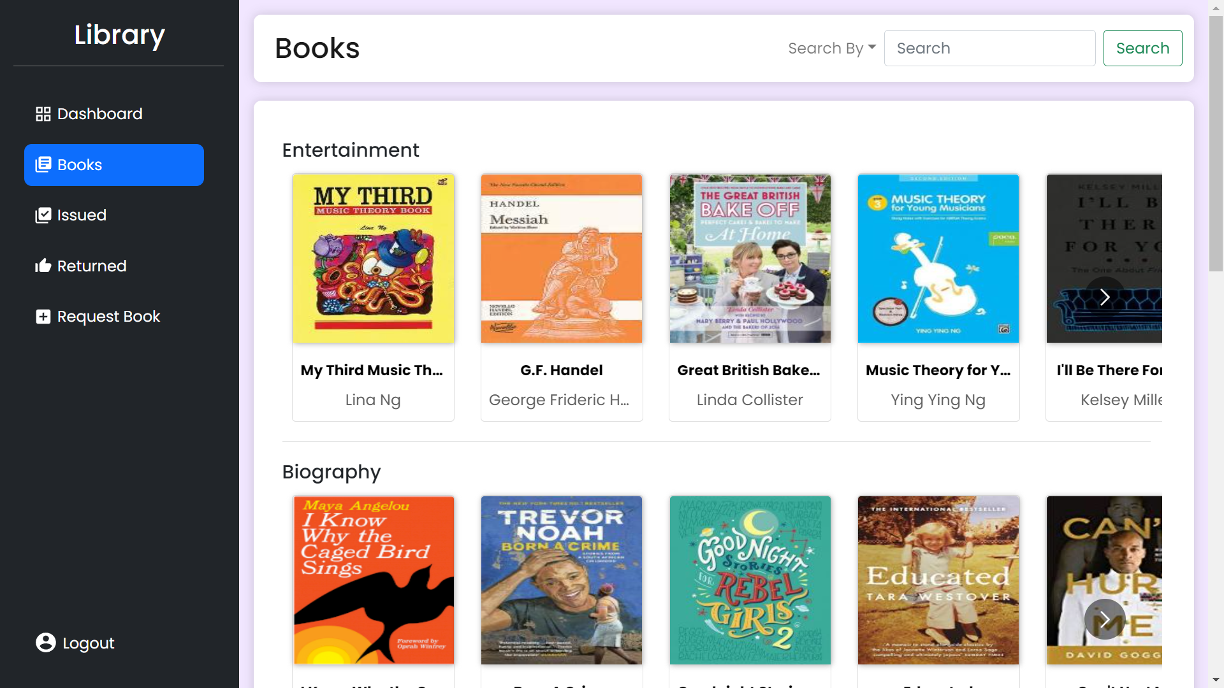

**BOOK DETAILS**

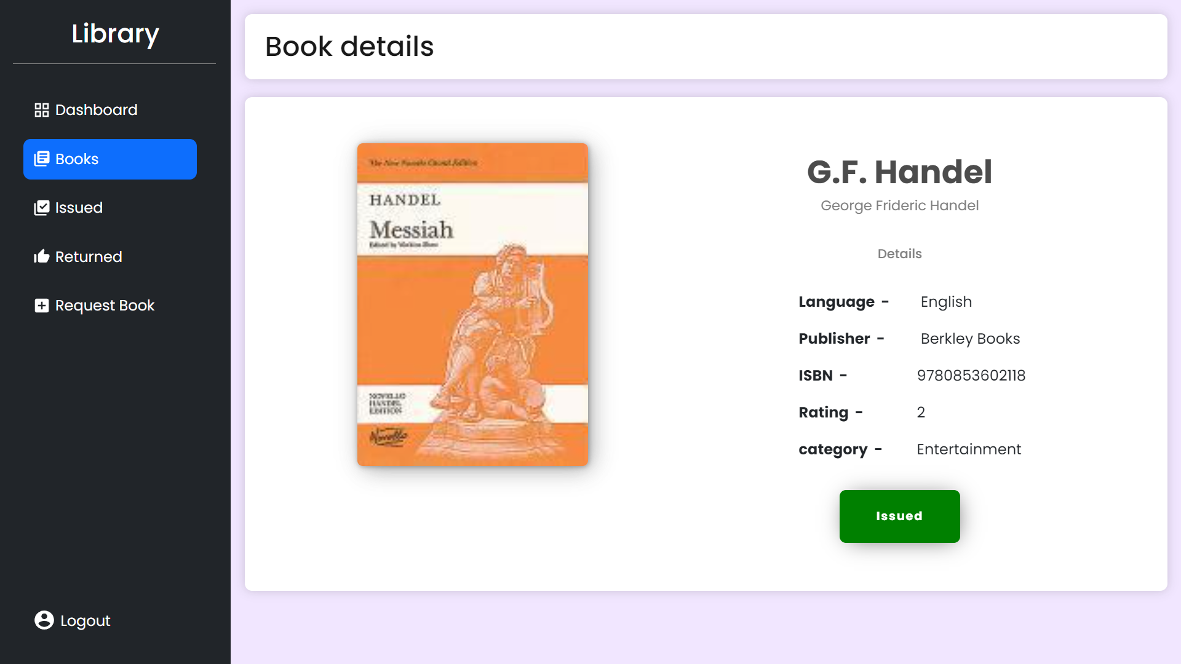

**ISSUED BOOKS**

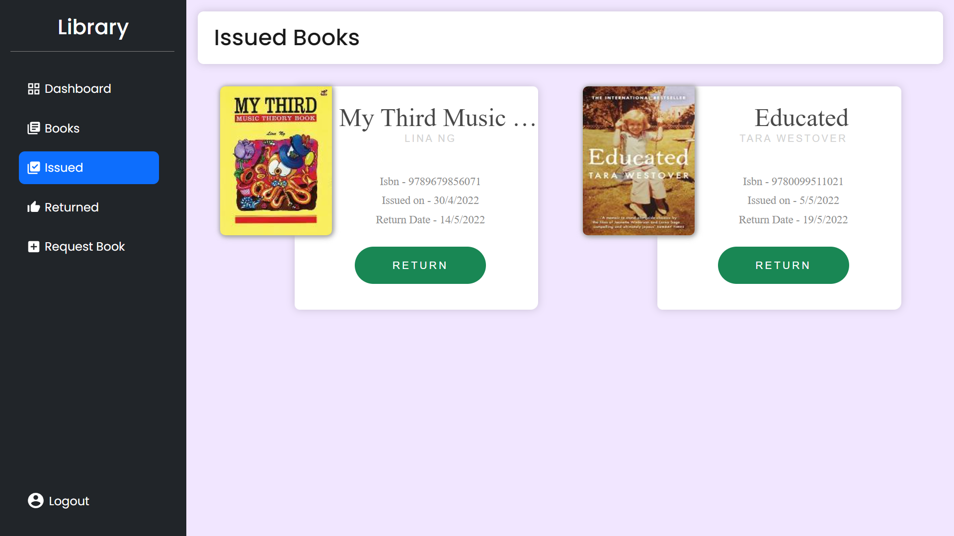

**RETURNED BOOKS**

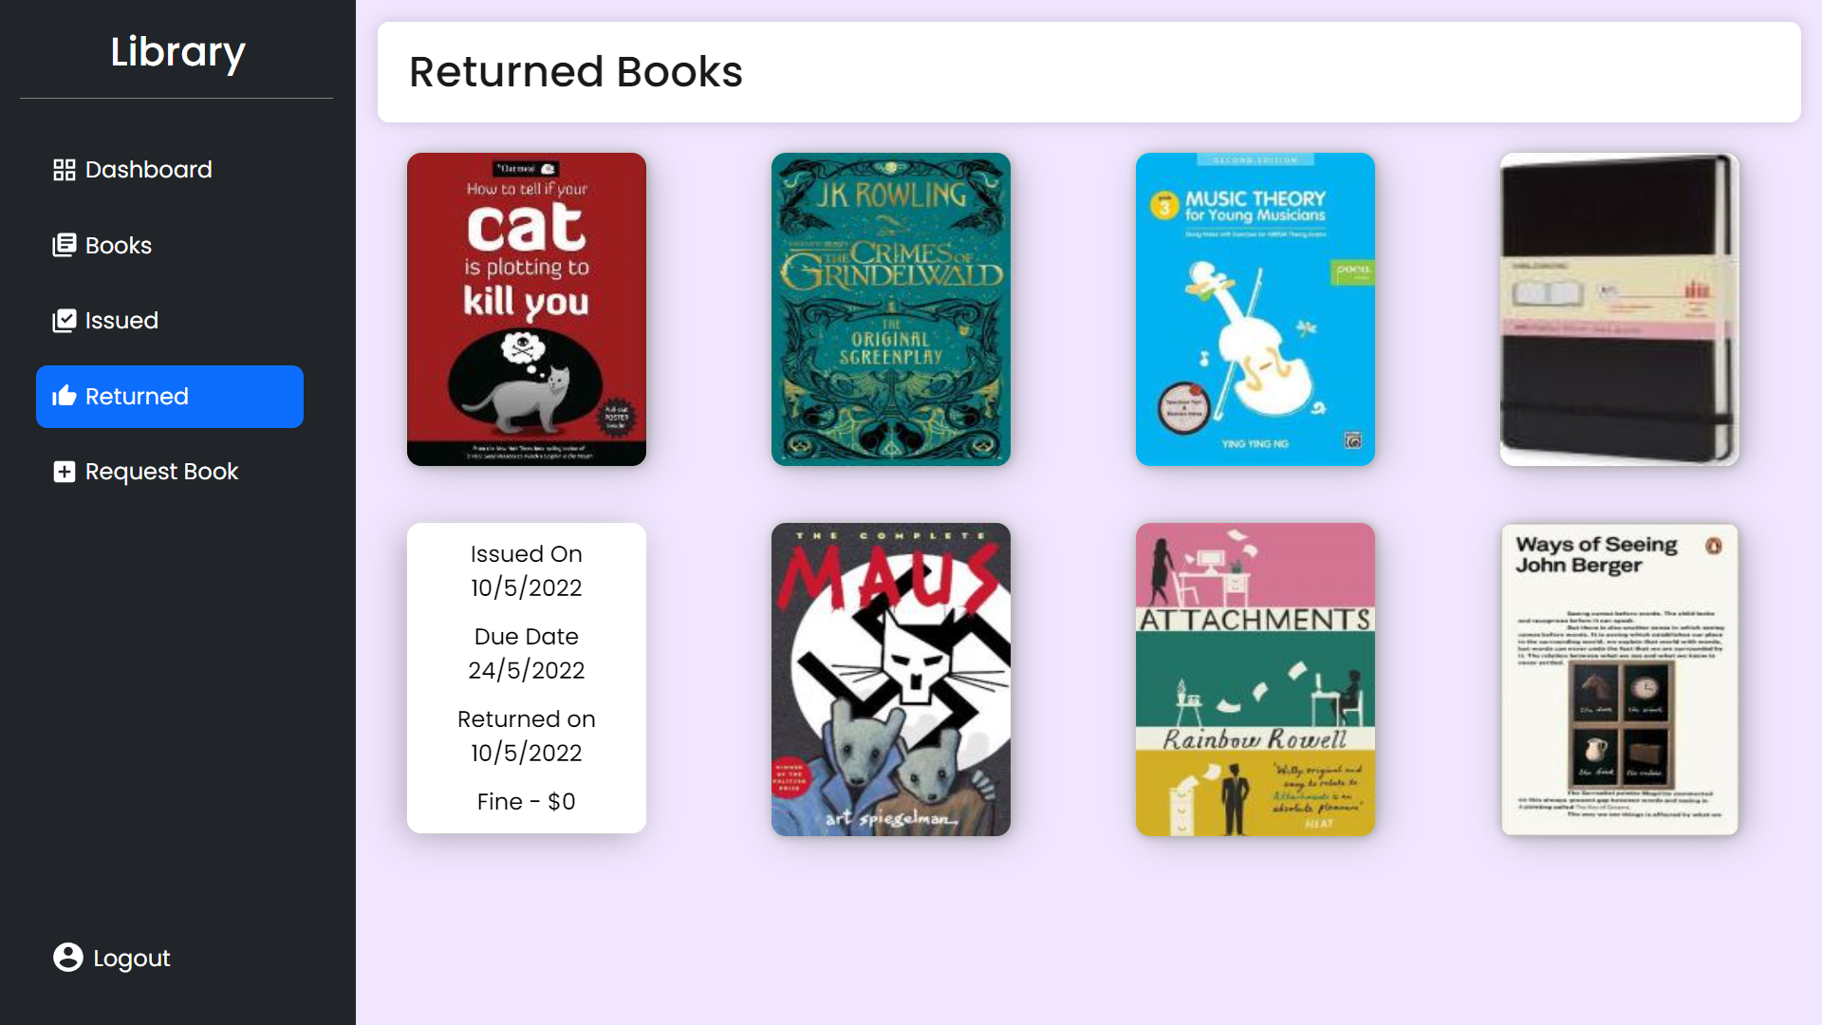

**REQUEST BOOKS**

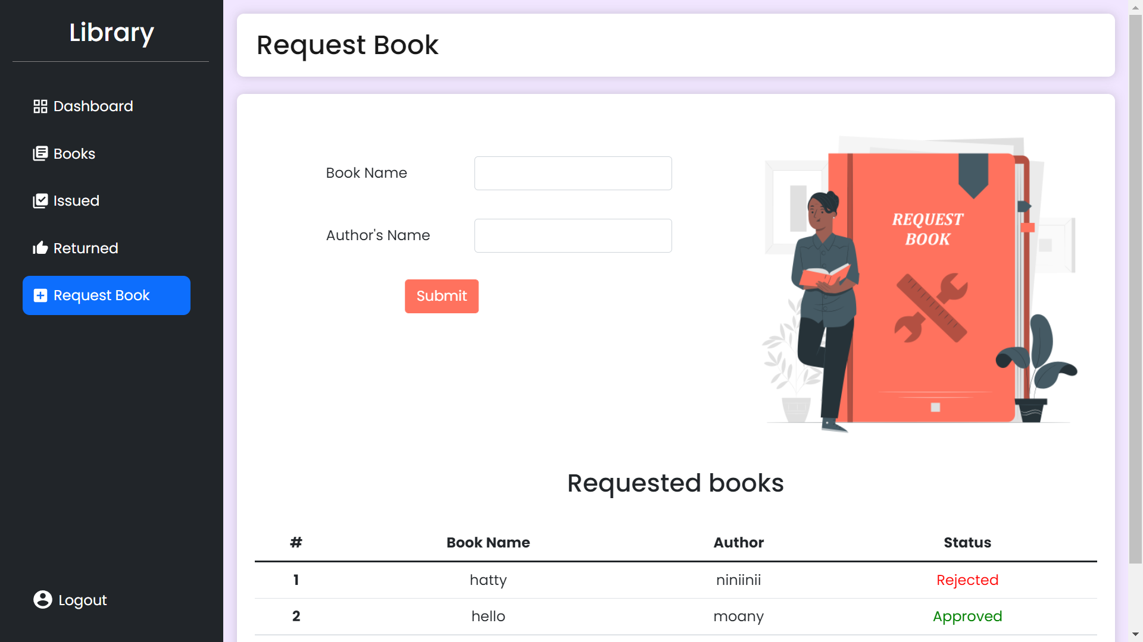

**—-------------------------------------- A D M I N —-------------------------------------**

**ADD A BOOK**

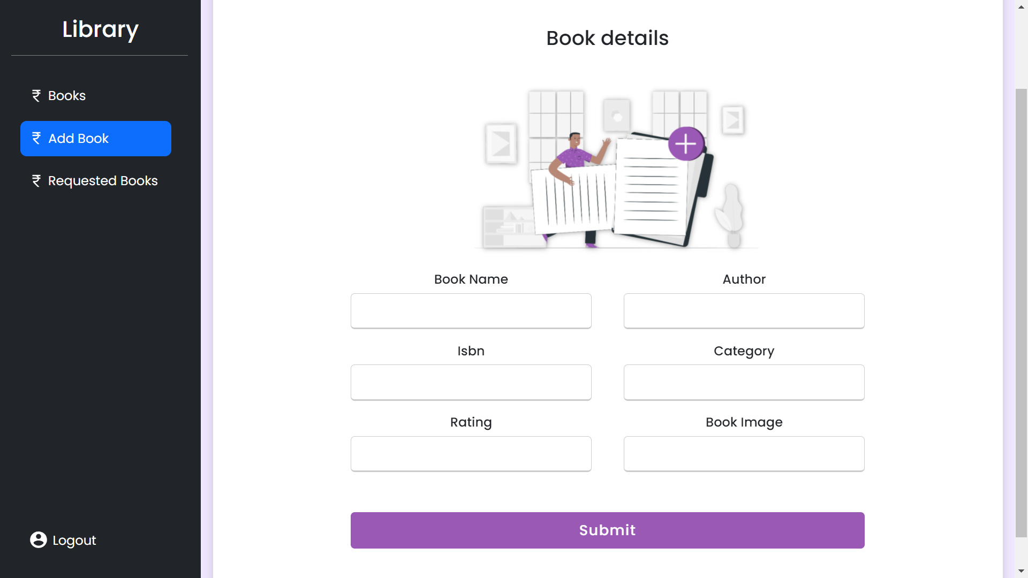

**REQUESTED BOOKS**

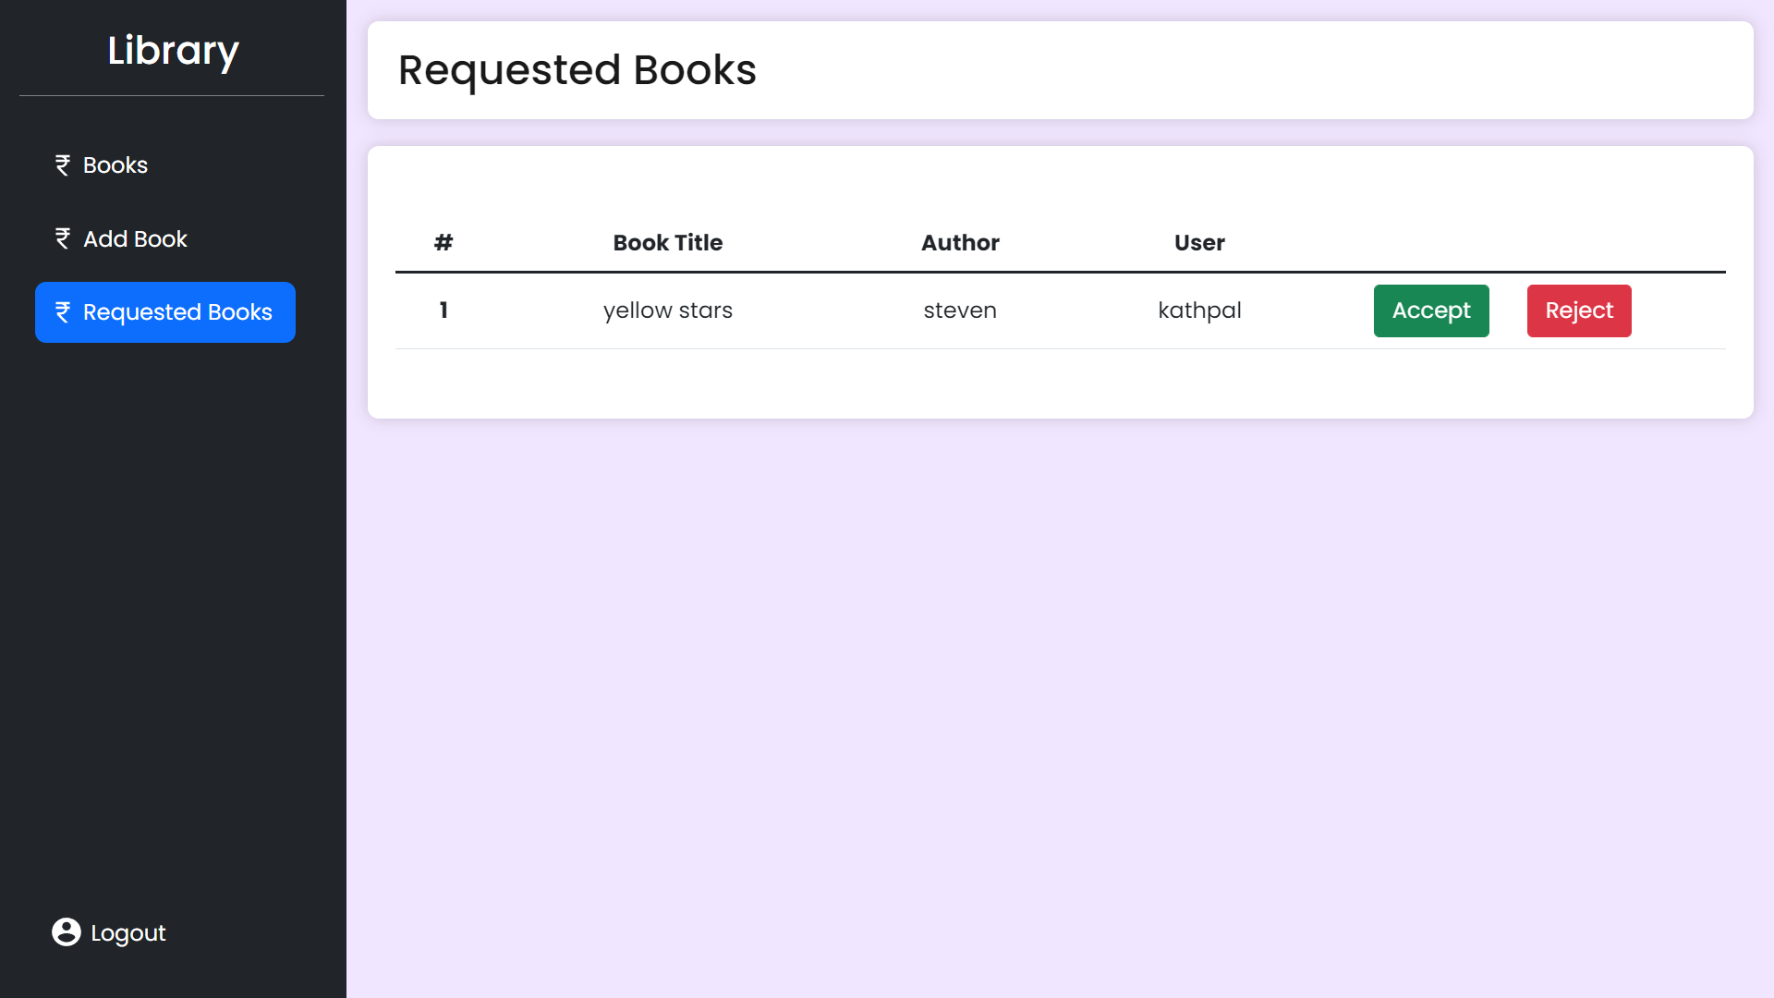

***7. FUTURE ENHANCEMENTS :***

**7.1. Online Fine Payment**

As a future endeavor this LMS will also serve as a platform for people who want to pay their fine via online payment.

**7.2. Book Maintenance Status**

Expand on providing an online book status by adding status for trash books or books under maintenance.

**7.3. Barcode Scanning**

To read the barcode easily using RFID sensors. The database is automatically updated when books are scanned while issuing or returning.

***8. CONCLUSION :***

In a traditional library the details of the members and the books in the library are recorded manually. The date of issue and return of books, overdue books, fines accrued are all entered in registers by the librarian and his assistants.

The library management system software records all this data. This saves time, effort and money. The librarian’s work becomes less tiresome. The automatic process reduces the chance of errors thereby increasing the accuracy of the records. The user-friendly interface increases member engagement and improves the efficiency of the library.

This web based library management system enables the librarian and the patrons to access the library from anywhere at one’s convenience. The software encompasses a whole gamut of functions which exposes the users to a wider collection of reading material.

The critical functions of cataloging and circulation of books are done by the library management system software. Entry of new books, deletion of old books and updating of the member and book database becomes simple. The books borrowed, returned, lost or misplaced can be tracked by the system.

Thus this system is highly efficient and provides desirable results. The use of MERN stack makes it highly scalable, robust and future ready.This application being built using popular frameworks can be easily deployed on various cloud platforms. Further features can be added and merged in this webapp.

***9. DATA SETS (Links)***

**9.1. Books Data**

<https://www.kaggle.com/datasets/lukaanicin/book-covers-dataset>

***10. BIBLIOGRAPHY :***

***10.1 Websites :***

1. https://www.educative.io/courses/grokking-the-object-oriented-design-interview/RMlM3NgjAyR
2. <https://www.skoolbeep.com/blog/library-management-system/>
3. <https://itechindia.co/blog/what-features-should-your-library-management-system-have/>
4. <https://reactjs.org/docs/getting-started.html>